Chapter 16, Solution 47.

Determine i_{o}(t) in the network shown in Fig. 16.70.

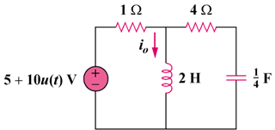

Figure 16.70
For Prob. 16.47.

Solution

We first find the initial conditions from the circuit in Fig. (a).

4

1
+

5 V

(a)

+

v_{c}(0)

i_{o}

,

We now incorporate these conditions in the s-domain circuit as shown in Fig.(b).

4/s

4

1
+

15/s

V_{o}

I_{o}

(b)

5/s

2s

At node o,

Equating coefficients :

:
:
:

[15 – 10e^{–0.6t}(cos(0.2t) – sin(0.2t))]u(t)

